**UNIVERSITI MALAYSIA TERENGGANU**

**Faculty Of Computer Sciences and Mathematics**

**Front End Programming**

**CSM3103**

Lab Report 5

**Prepared by:**

Muhammad Imran Bin Abd Hamid (S66803)

Bachelor of Computer Science (Mobile Computing) with Honors.

Sem 2 2023/2024

Task 1

Output:

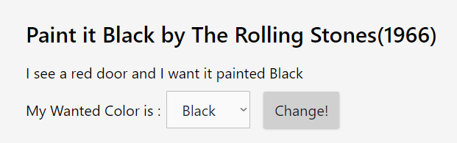

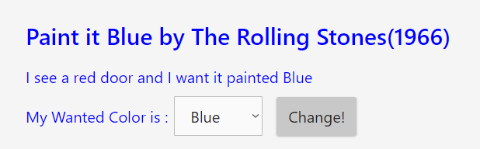

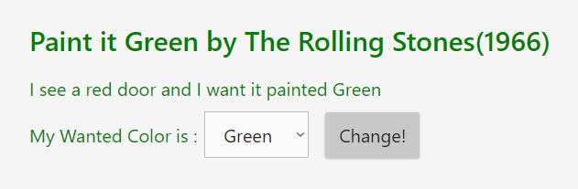

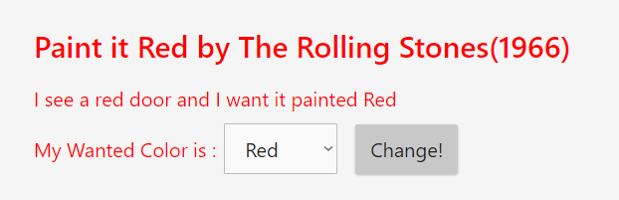

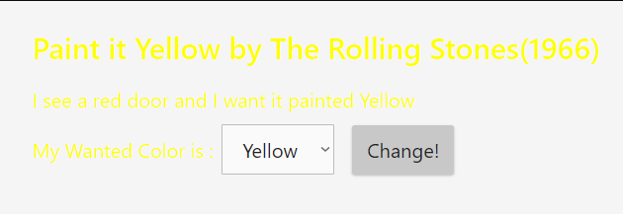

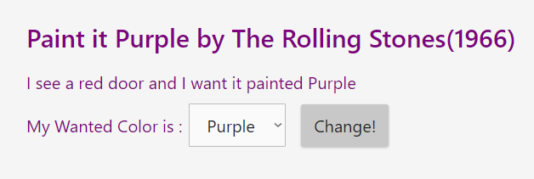

Task 2

Output:

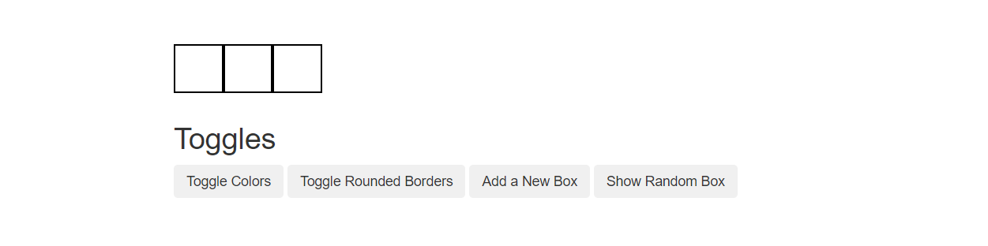

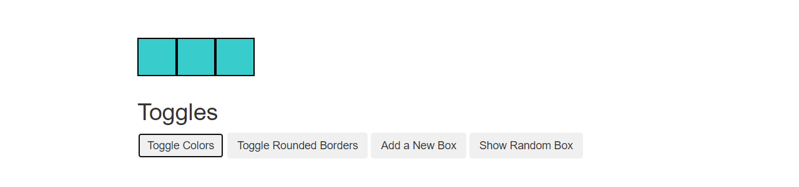

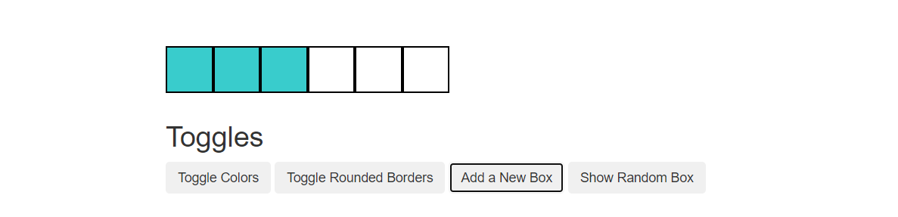

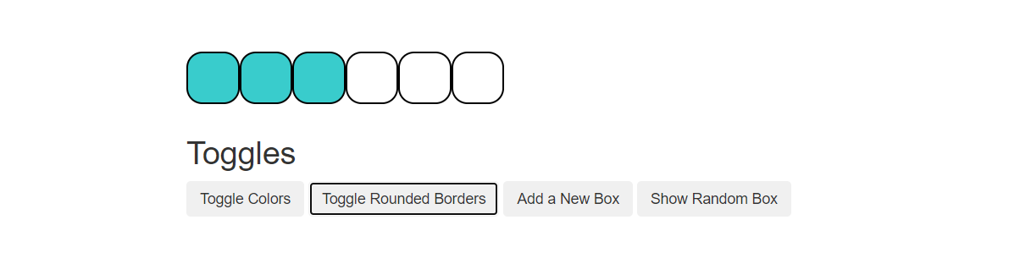

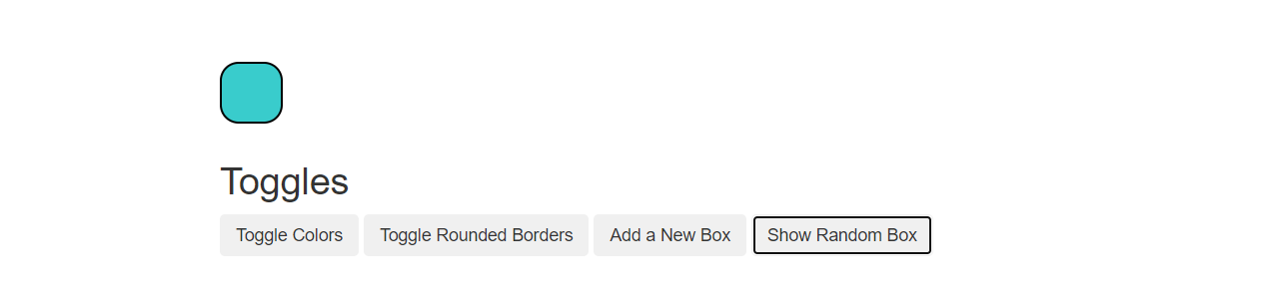

Task 3

Output:

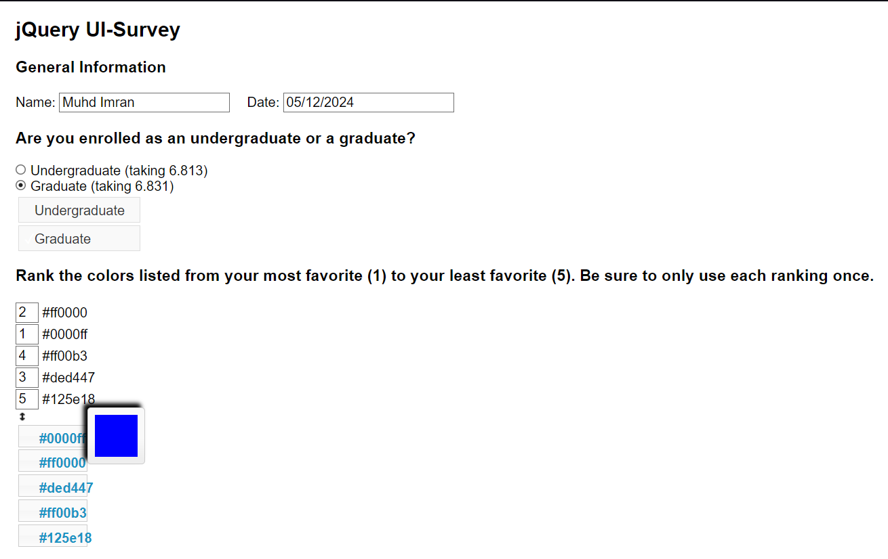

Task 4

Output:

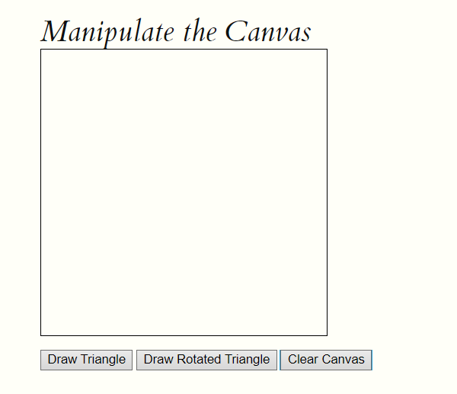

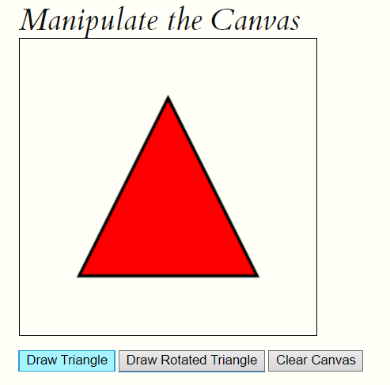

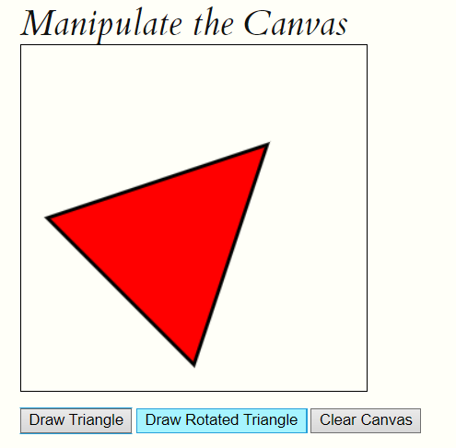

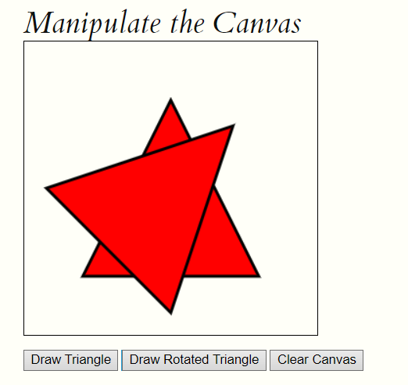

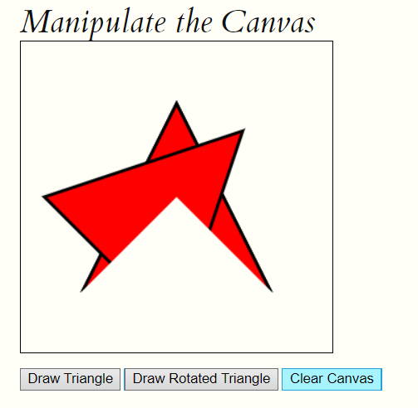

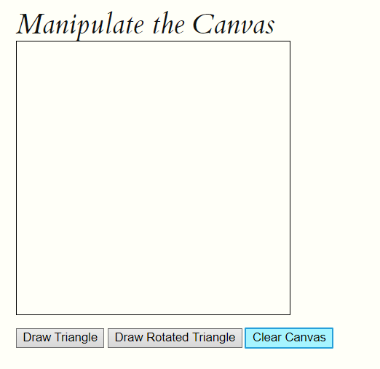

Link Github: <https://github.com/S66803/CSM3103-Front-End->